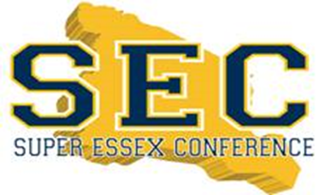

ALL CONFERENCE SELECTIONS

Sport: Boys Lacrosse COLONIAL DIVISION | Year: 2022

Division: COLONIAL

FIRST TEAM:
Name (First Last) | School
1. Matt Pergola | Nutley
2. Jake Cirminiello | Nutley
3. Rocco Albanese | Nutley
4. Jack Ponzoni | Nutley
5. Angel Castillo | East Side
6. Saboor Karriem | West Orange
7. Zander Lipsey | West Orange

SECOND TEAM:

Name (First Last) | School
1. Joseph Alberti | Nutley
2. Eddie Kaminski | Nutley
3. Rayel Hunter | West Orange
4. Daniel Bienanime | West Orange
5. Nicholas Wilson | Nutley
6. Thomas Devlin | Nutley

HONORABLE MENTION: 1 per school

School | Name (First Last)
1. Nutley | Jack Kirk
2. West Orange | Remy Frolow
3. Newark Academy | Justin Blann
4. East Side | Santiago Lema

